**SCHOLARSHIP STUDENTS**

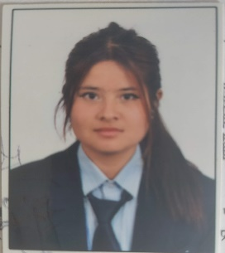

1. NAME: BINITA RAI

CLASS: TWELVE

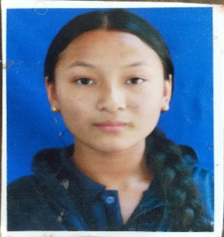2. NAME: MANJU THING

CLASS: ELEVEN

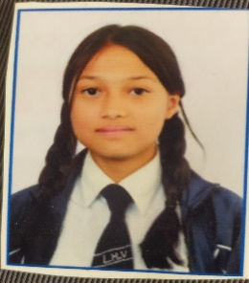3. NAME: UPASANA MAHARJAN

CLASS: CIVIL DIPLOMA

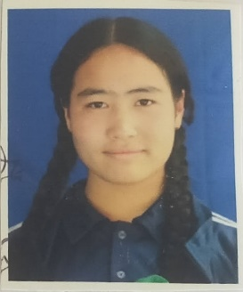4. NAME: RADHIKA KUMARI THAPA

CLASS: TEN

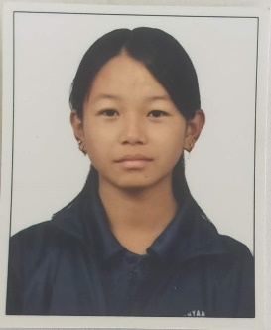5. NAME: SIMRAN RAI

CLASS: TEN

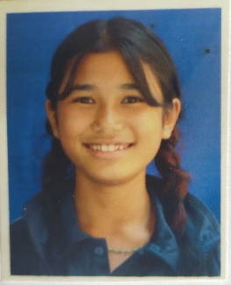6. NAME: SARIKA THAPA

CLASS: NINE